**Lab Exercise 18- Scanning IaC Templates for Vulnerabilities**

**Name- Arin Agrawal**

**SAP ID- 500120660**

**Batch- 1**

## Objective

* Learn how to scan Infrastructure as Code (IaC) templates for security vulnerabilities.
* Use open-source IaC security tools to detect misconfigurations.
* Understand common risks such as public access, unencrypted resources, and insecure network rules.





## Step 1: Create an Insecure IaC Template

Create a file named main.tf with the following Terraform code:









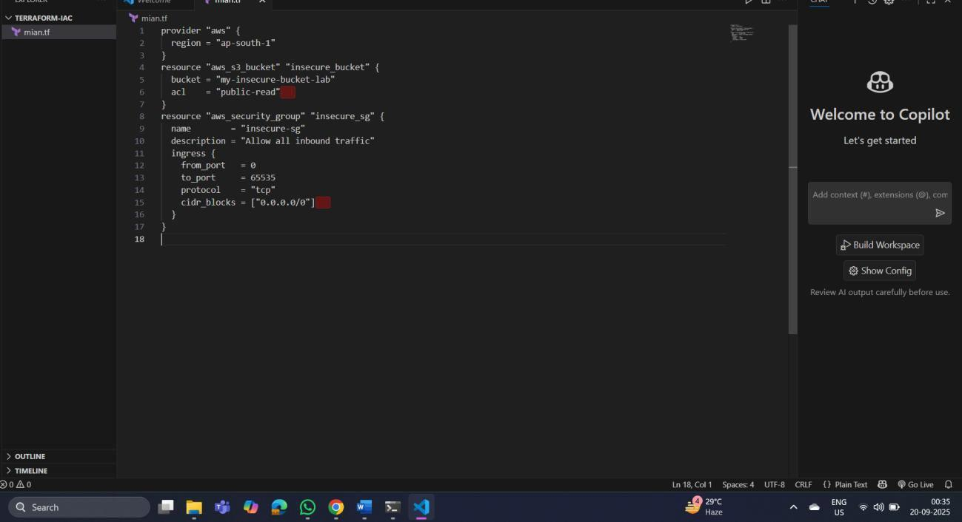



## Step 2: Scan the Template with Checkov

Run Checkov on the current directory:



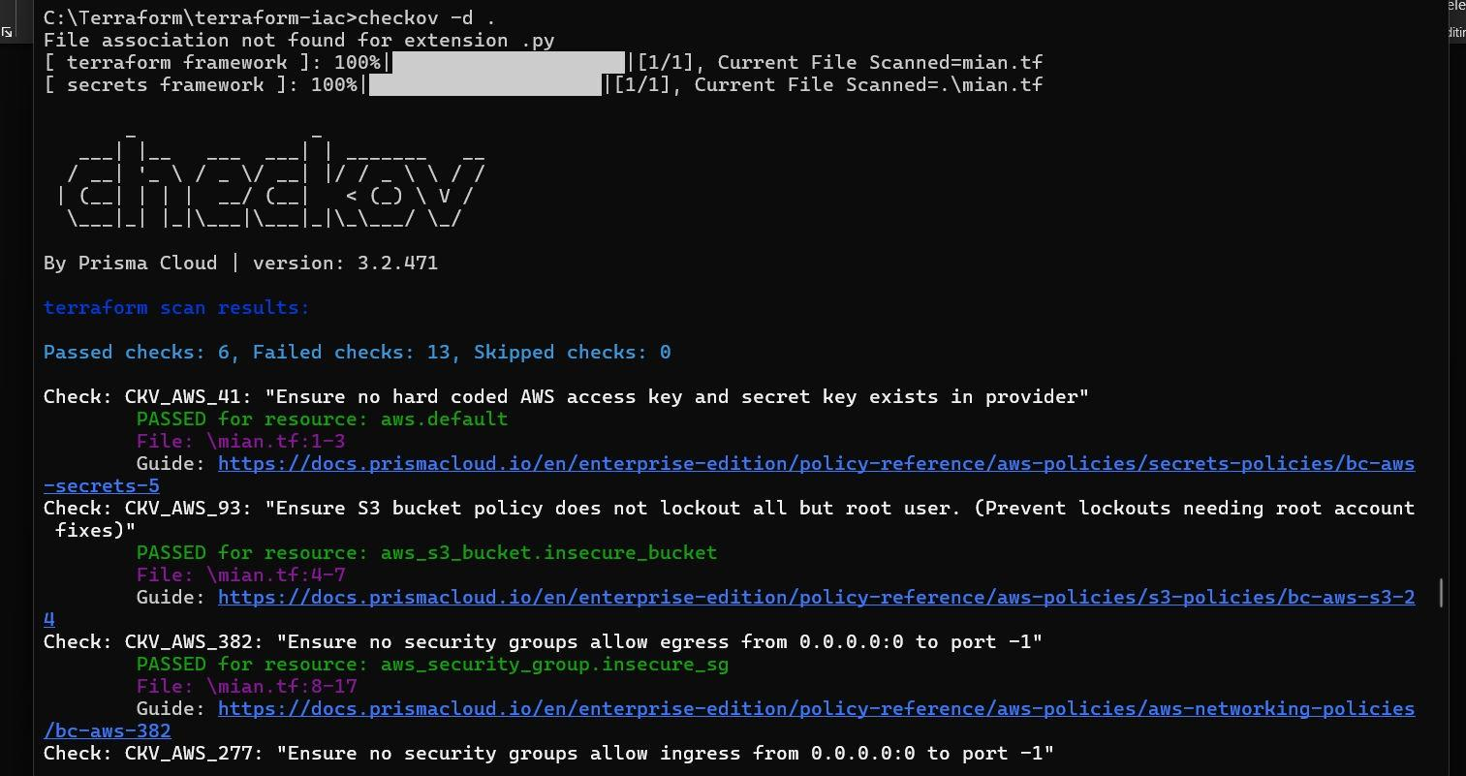

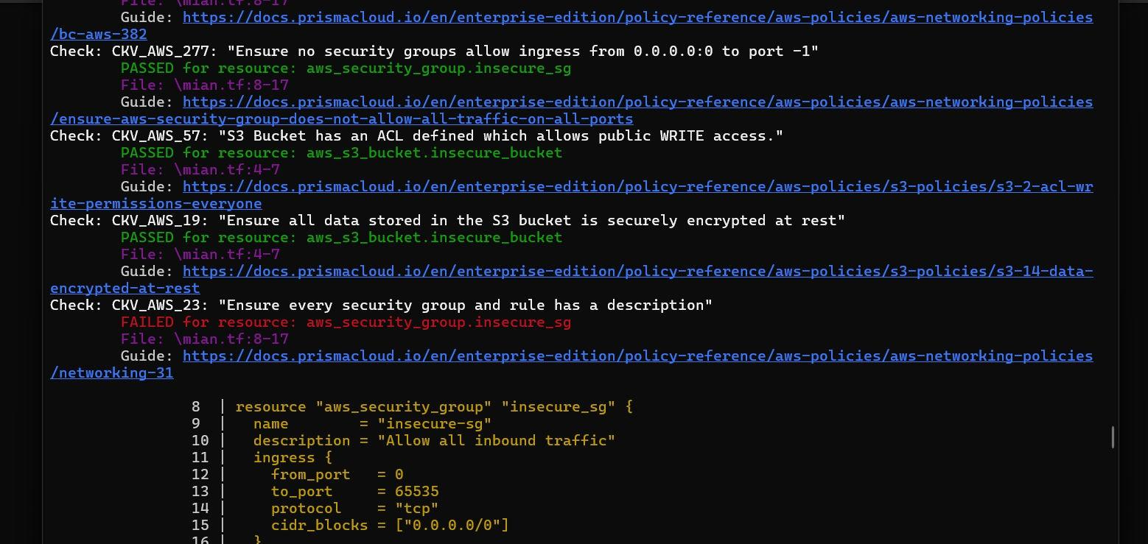



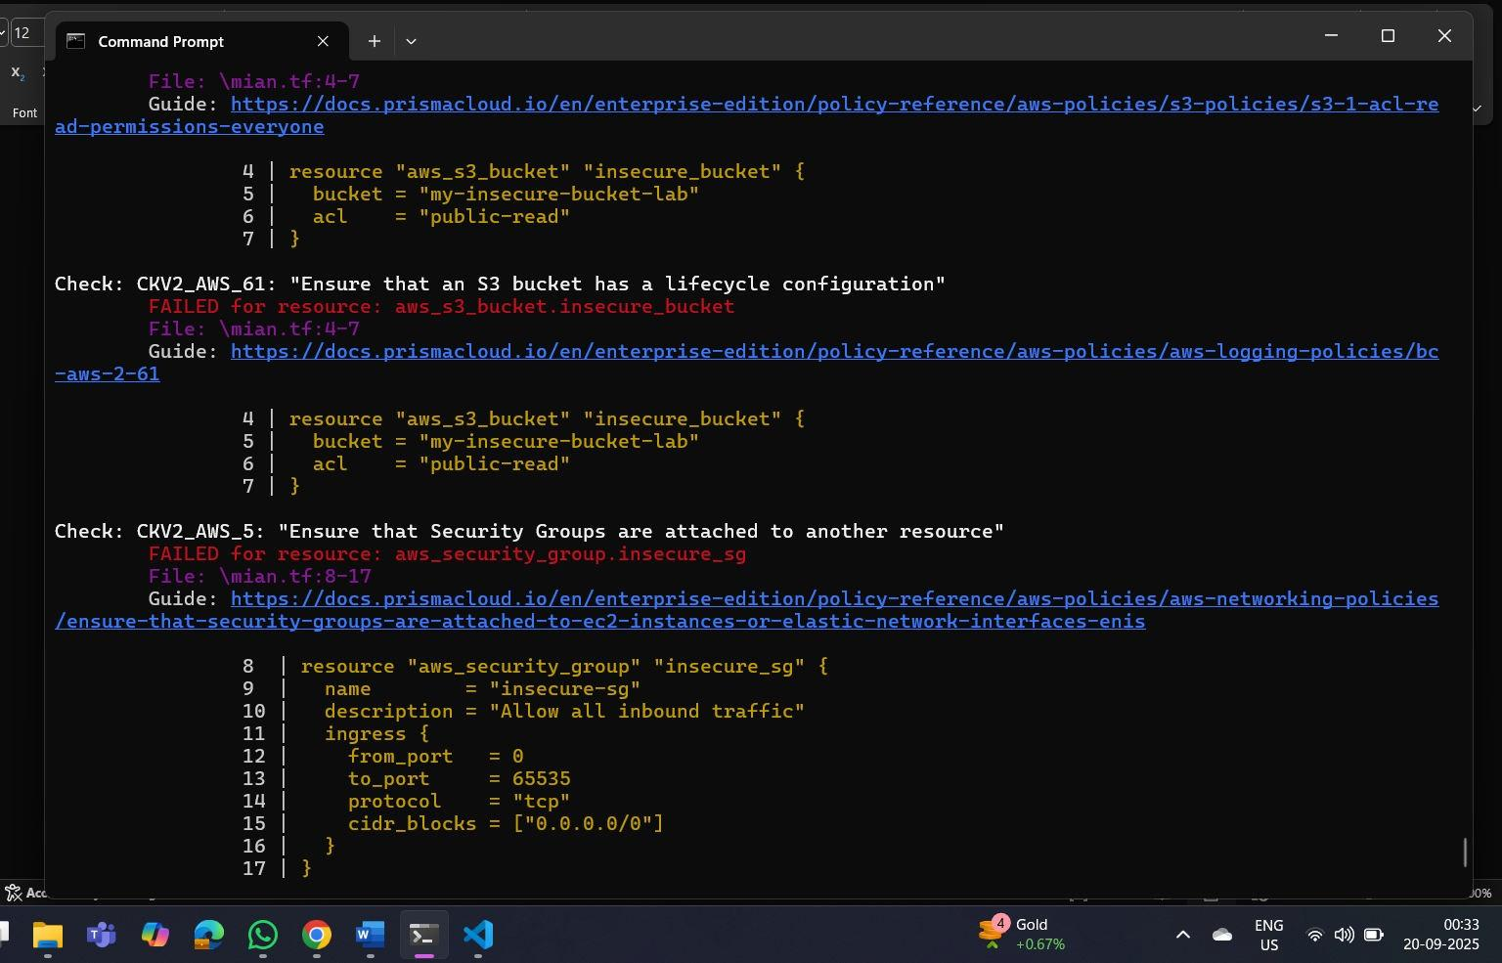

## Expected Findings:

* Public S3 bucket access (public-read)
* Security group open to all inbound traffic



## Expected Findings:

* Warns about S3 bucket without encryption
* Flags open Security Group rules



## Step 4: Review the Report

Example output (Checkov):





## Step 5: Apply Fixes (Optional)

Modify the IaC template to:

* + Set S3 bucket ACL to private
  + Enable encryption (AES256)
  + Restrict Security Group to specific IP ranges



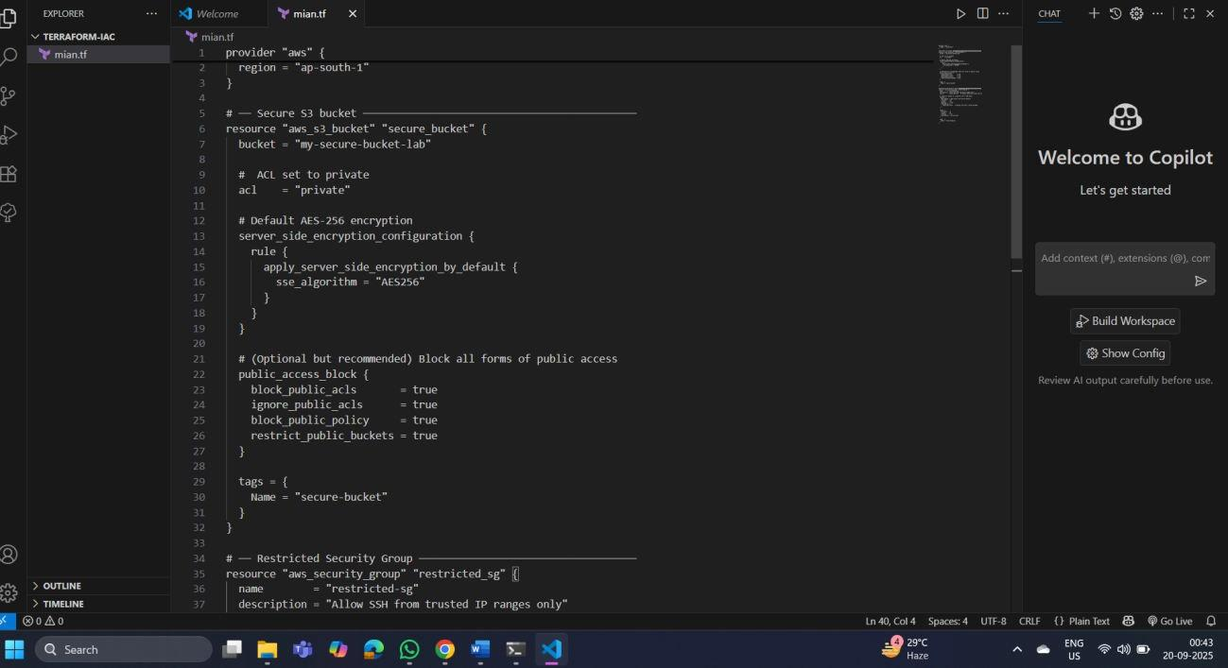

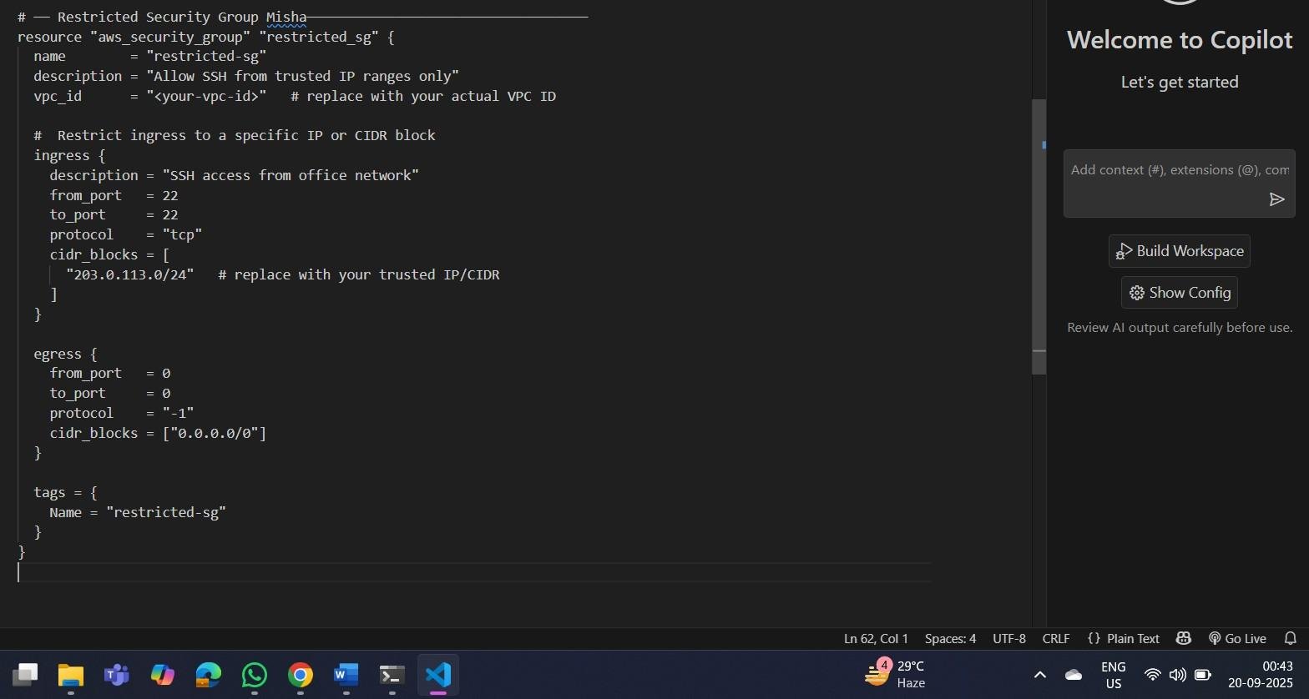



## Step 6: Rescan the Template

Run the scan again:



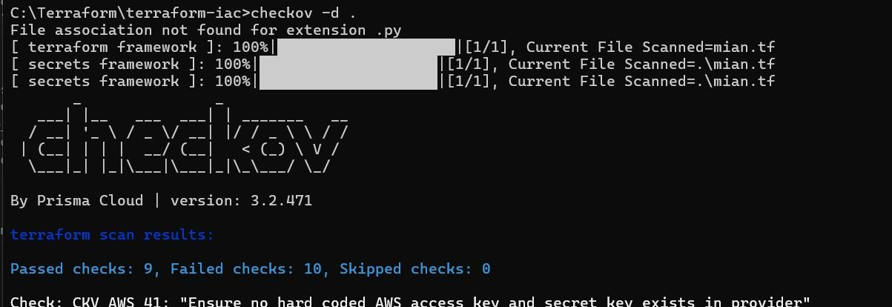

Now the findings should be **resolved or reduced**.



## Step 7: Document Findingss

Create a simple findings log:

**Before** the securing, terraform scan results

**Passed** checks: **6**, **Failed** checks: **13**, Skipped checks: 0

**After** securing- terraform scan results:

**Passed** checks: **9**, Failed checks: **10**, Skipped checks: The number of failed test checks reduced,.